

|  |  |
| --- | --- |
| Name: | Rao Muhammad Rafay |
| Reg No | Sp22-Bcs-067 |
| Instructor: | Mam Yasmeen Jana |
| Date: | 25/10/2023 |
| LAb | Mid |

COMSATS University Islamabad

Vehari Campus

Question No 1:

To create a single linked list using “SSL” Function …

Answer:

#include <iostream>

using namespace std;

const int MAX_SIZE = 5;

class Stack{

private:

int top;

int arr[MAX_SIZE];

public:

Stack() {

top = -1;

}

bool isEmpty() {

return top == -1;

}

bool isFull() {

return top == MAX_SIZE - 1;

}

void push(int data) {

if (isFull()) {

cout << "Stack is full. Cannot push." << endl;

return;

}

arr[++top] = data;

}

void pop() {

if (isEmpty()) {

cout << "Stack is empty. Cannot pop." << endl;

return;

}

--top;

}

int peek() {

if (isEmpty()) {

cout << "Stack is empty. Cannot pop." << endl;

return 0;

}

//cout<<arr[top]<<" ";

return arr[top];

}

int display() {

if (isEmpty()) {

cout << "Stack is empty. Cannot Display." << endl;

return -1;

}

int display=top;

while(display!=-1){

cout<<arr[display]<<" ";

display--;

}

}

};

class Node {

public:

int data;

Node* next;

Node(int data) {

this->data = data;

this->next = NULL;

}

};

class LinkedList {

public:

Node* head;

Stack stack;

LinkedList() {

head = NULL;

}

void insert(int data) {

Node* newNode = new Node(data);

if (head == NULL) {

head = newNode;

}

else {

Node* temp = head;

while (temp->next != NULL) {

temp = temp->next;

}

temp->next = newNode;

}

}

void SSL(){

Node* temp=head;

while(temp!=NULL){

stack.push(temp->data);

temp=temp->next;

}

stack.display();

}

void palindrome(){

Node* temp=head;

int a=0;

while(temp!=NULL){

if(temp->data==stack.peek()){

temp=temp->next;

stack.pop();

}

else{

cout<<"\nThe Given Linked List Is Not Palindrome"<<endl;

a=5;

return;

}

}

if(a==0){

cout<<"\nThe Given Linked List Is Palindrome";

}

}

void display() {

Node* temp = head;

while (temp != NULL) {

cout << temp->data << " ";

temp = temp->next;

}

cout<<endl;

}

};

int main() {

LinkedList list;

list.insert(1);

list.insert(2);

list.insert(2);

list.insert(1);

cout << "\nOriginal list: ";

list.display();

cout << "\nReverse list: ";

list.SSL();

list.palindrome();

return 0;

}

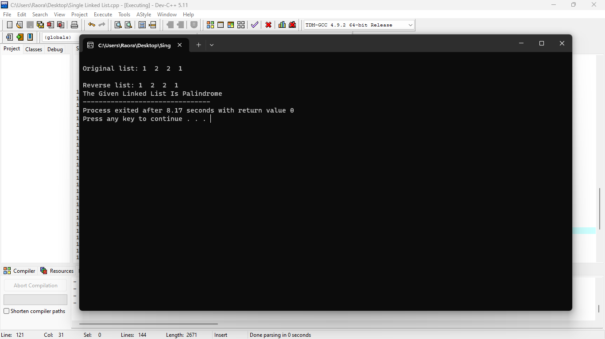

Question no 2:

Simple Stack function

Answer:

#include <iostream>

using namespace std;

const int MAX_SIZE = 100;

class Stack{

private:

int top;

int arr[MAX_SIZE];

public:

Stack() {

top = -1;

}

bool isEmpty() {

return top == -1;

}

bool isFull() {

return top == MAX_SIZE - 1;

}

void push(int data) {

if (isFull()) {

cout << "Stack is full. Cannot push." << endl;

return;

}

arr[++top] = data;

}

void pop() {

if (isEmpty()) {

cout << "Stack is empty. Cannot pop." << endl;

return;

}

--top;

}

int peek() {

if (isEmpty()) {

cout << "Stack is empty. Cannot peek." << endl;

return -1;

}

return arr[top];

}

int display() {

if (isEmpty()) {

cout << "Stack is empty. Cannot Display." << endl;

return -1;

}

int display=top;

while(display!=-1){

cout<<arr[display]<<endl;

display--;

}

}

};

int main() {

Stack stack;

cout << "Stack operations:" << endl;

cout << "1. Push" << endl;

cout << "2. Pop" << endl;

cout << "3. Peek" << endl;

cout << "4. Is Full" << endl;

cout << "5. Is Empty" << endl;

cout << "6. Diplay" << endl;

cout << "7. Quit" << endl;

int choice, data;

do {

cout << "Enter your choice operation: ";

cin >> choice;

switch (choice) {

case 1:

cout << "Enter data to push: ";

cin >> data;

stack.push(data);

break;

case 2:

stack.pop();

break;

case 3:

cout << "Top element: " << stack.peek() << endl;

break;

case 4:

if (stack.isFull()) {

cout << "Stack is full." << endl;

} else {

cout << "Stack is not full." << endl;

}

break;

case 5:

if (stack.isEmpty()) {

cout << "Stack is empty." << endl;

} else {

cout << "Stack is not empty." << endl;

}

break;

case 7:

cout << "Exiting program." << endl;

break;

case 6:

cout << "Elements in Stack Are :" << endl;

stack.display();

break;

default:

cout << "Invalid choice. Please try again." << endl;

}

} while (choice != 6);

return 0;

}



